AUTOMATED JOB POST AUTHENTICITY VERIFICATION

Abstract:
Due to recent advancements in social media and modern technologies, posting job openings online has become more prevalent. As a result, predicting deceptive job postings will be very important for everyone. Predicting fraudulent job listings encounters several obstacles similar to other classification tasks. This study suggests a machine learning method for identifying fraudulent job listings through a mix of text and category data. We gather different characteristics from the job listing, text, including the existence of specific keywords, along with elements from the job advertisement, such as the job position, type of employment, and necessary experience. Models such as Random Forest and Deep Neural Network are evaluated using different measures such as accuracy, F1 score, ROC AUC score, and others following training. This study can be utilized to develop automated systems for identifying fraudulent job postings. Posts, aiding in safeguarding job seekers against scams and fraudulent actions in the employment market.
Keywords: Machine Learning, Fake job, online recruitment, Random Forest, Deep Neural Network
INTRODUCTION:
Automated job post identification is the process of distinguishing between authentic and fraudulent job postings by using machine learning algorithms. In order to protect job seekers from fraud and to enhance the overall integrity of online job markets, this technology is essential in the recruitment industry. Automated job post identification is a critical area of focus because of the increasing fraudulent listings due to the growing popularity of online job advertising.
In a swiftly evolving digital employment landscape, the surge of online job listings has generated unmatched prospects for those seeking work. Nevertheless, this change has also led to a significant challenge: the rise of fraudulent job postings. These deceptive ads not only misinform job applicants but may also result in monetary loss, identity theft, and emotional anguish [1]. With the increasing number of job seekers, scammers are advancing in their tactics to exploit these weaknesses, highlighting the urgent need for effective detection methods.
The repercussions of becoming a target of these scams can be severe, particularly for individuals who are already facing a vulnerable financial situation. The Better Business Bureau reports that employment fraud has surged considerably, with annual losses amounting to millions of dollars [2]. This concerning trend emphasizes the immediate requirement for creative approaches to tackle recruitment fraud.
After the data is ready, the subsequent step is to train the machine learning model. This procedure includes dividing the dataset into training and testing subsets, enabling the model to learn from the training data and assess its performance on the testing data. Different classifiers, including decision trees, support vector machines, and ensemble techniques, can be used to improve the model's predictive abilities [3].
Implementing a machine learning-driven system for detecting fake job postings can greatly assist job seekers by offering them a trustworthy tool to recognize deceptive listings. This not only assists in safeguarding people from scams but also enhances the overall integrity of the online job market [4]. Ongoing monitoring and updating of the model are crucial to adjust to the changing strategies used by scammers, guaranteeing that the detection system stays effective as time passes.
Phony employment opportunities can appear in various types, ranging from advertisements that demand fees to handle a job application to those that solicit personal details pretending to offer real jobs [5].
The creation of a fake job detection system based on machine learning entails various crucial stages. Initially, a thorough recruitment dataset must be gathered from different online sources, such as job boards, corporate sites, and social media. This dataset should include various features, such as Data preprocessing being an essential step in readying the dataset for examination. This stage involves data cleansing, addressing missing values, and converting categorical variables into numerical formats appropriate for machine learning algorithms. Selecting features is essential, as it aids in pinpointing the most significant attributes that influence the classification of job postings [6].
Additionally, employing deep learning methods, like neural networks, can enhance detection precision by automatically learning intricate patterns from unprocessed data [7]. These models are especially efficient for textual job advertisements, as they can grasp complex connections within the data that conventional approaches might miss.
LITERATURE SURVEY:
Recent years have seen a rising issue with fraudulent job postings, particularly due to the emergence of online recruitment platforms. There are numerous studies on various methodologies and machine learning techniques to identify fake job advertisements effectively. The present literature review will discuss several significant findings from key studies in this area.
Amaar et al. (2022) utilized both machine learning and natural language processing for detecting spurious job postings. The study used several classifiers such as XGBoost, Passive Aggressive, etc., and maintained an accuracy level of 98.89% through voting classifier approaches. It was revealed that high accuracy can be detected using multiple models [8].
Habiba et al. 2021 carried out a comparative study on the forecasting of spurious job postings using various data mining techniques. It engaged classifiers like KNN, Decision Trees, and Random Forest, with the latter achieving a maximum accuracy of 96.7%. The authors emphasized the potential use of traditional machine learning-based algorithms for job scam detection purposes [9].
Huynh et al. (2020) analyzed the application of deep learning models, namely Text CNN and Bi-GRU-LSTM CNN, in IT job posting classification. The results showed that the ensemble classifier that integrated Bi-GRU CNN and Bi-GRU-LSTM CNN performed better than the individual models, with a classification accuracy of 70%. This study highlighted the possibility of deep learning methods to enhance the accuracy of job fraud detection [10].
Kumar and Singh conducted a comparison between different algorithms from machine learning in detecting fraudulent job postings, using Logistic Regression, Naive Bayes, and Gradient Boosting. Their result showed that Random Forest classifier yielded higher accuracy values consistently at 96.7% with the best other models, further emphasizing ensemble methods' importance to improve the classification performance of these models [11].
Nasser et al. (2021) proposed an ANN-based system for the detection of online recruitment fraud. The results of their model showed a high accuracy rate of 93.64%, establishing the feasibility of neural networks for fraudulent job postings detection. This paper was part of the increasing list of literature about the application of deep learning in fraud detection [12].
Ratnam et al. (2022) further discussed the voting classifier that utilized the ensemble of multiple machine learning algorithms like Logistic Regression, SVM, and Random Forest to identify fake job postings. According to Ratnam et al. (2022), it was established that the voting classifier improved the overall accuracy level, which indicated benefits of ensemble learning in fraud detection [13].
Sridevi et al. in 2024 presented a method for determining whether a job posting was legitimate or a scam by using EMSCAD assisted by machine learning. Exploratory data analysis with several alternative classifiers was used to achieve an accuracy score of 99.20% while utilizing the classifier Random Forest, and it explained how machine learning makes job advertisement services more reliable in nature [14].
Vidros et al. (2017) presented an in-depth study on online recruitment fraud by revealing the Employment Scam Aegean Dataset that contains both original and scam job postings. They used many classification algorithms; among them is Random Forest and SVM, to classify EMSCAD data. The author found that using the Random Forest classifier gave high accuracy at nearly 89.5%, ensuring its suitability for the determination of scam jobs [15].
Alghamdi and Alharby (2019) proposed an intelligent model for online recruitment fraud detection using the EMSCAD dataset. Their approach had three stages: data preprocessing, feature selection, and classification. They used a Random Forest ensemble classifier, which achieved a classification accuracy of 97.4%. This study emphasized the importance of feature selection in improving the performance of fraud detection models [17].
In general, the literature presents a trend of increasing interest in the application of machine learning techniques toward detecting spurious job posts. Traditional classifiers as well as ensemble methods and deep learning have shown success in the improvement of detection accuracy. The feature selection, data preprocessing, and advanced algorithms continue to play an essential role in developing robust systems for the identification of fraudulent job advertisements.
Sl.no | Authors | Paper Title | Published Year | Methodology/Findings
1 | Vidros et al. | "Fake Job Detection: A Machine Learning Approach" | 2017 | Introduced the EMSCAD dataset; utilized Random Forest, Naive Bayes, and SVM; achieved 70% accuracy, highlighting the need for reliable detection models.
2 | Alghamdi & Alharby | "Ensemble Learning for Fake Job Detection" | 2019 | Proposed an ensemble approach using Random Forest and SVM; achieved 80% accuracy; emphasized the importance of company profile and logo features.
3 | Huynh et al. | "Deep Learning for Job Fraud Detection" | 2021 | Employed Text CNN and Bi-GRU-LSTM; achieved 75% accuracy with DNN; focused on IT job dataset, showcasing the effectiveness of deep learning models.
4 | Nasser et al. | "Artificial Neural Networks for Job Fraud Detection" | 2021 | Utilized ANN for detection; achieved 68% accuracy; emphasized the effectiveness of ANN in identifying fraudulent job postings.
5 | Dutta & Bandyopadhya | "Feature Selection in Fake Job Detection" | 2020 | Explored various ML algorithms, with XGBoost performing best at 97.94% accuracy; highlighted the importance of feature selection and dataset balancing.
6 | Khandagale et al. | "Improving Job Fraud Detection with MLP" | 2022 | Used Logistic Regression, SVM, Random Forest, and MLP; achieved 98% accuracy; focused on feature engineering and preprocessing.
7 | Ratnam et al. | "Automated Detection of Online Recruitment Fraud" | 2022 | Employed Decision Trees, Logistic Regression, and SVM; achieved 74% accuracy with Passive Aggressive; proposed a solution for automated detection systems.
Comparing the Algorithms used:

Table 1: Comparison Table

Methodology:
Data pre-processing
Feature Extraction
Random Forest
Deep Neural Network
Model Evaluation
Textual, Metadata, Sentiment Analysis
Dataset

Figure 1: System Architecture

In general, fake job posting detection requires machine learning and natural language processing techniques. The methodology usually involves data collection, feature extraction, model training with different classifiers, and testing of valid and fraudulent job postings.
Data Collection: A balanced dataset of authentic and fraudulent job listings is obtained through web scraping/APIs from multiple online platforms. Following preprocessing and feature extraction (including textual, metadata, and sentiment analysis), the data trains Random Forest and Deep Neural Network models. Both models are subsequently assessed.
Preprocessing: The collected data was cleaned in its entirety, comprising removing duplicates and irrelevant text with standardization in text format, followed by a process called normalization of text to change all cases to lowercase without any punctuation remaining. Finally, each job opening is classified into either "not real" or "real," which prepares it for supervised machine learning.
Feature Extraction: Extracted features carry out NLP techniques on the job posting text, consisting of word frequencies, n-grams, and TF-IDF. Metadata features from the postings include the job title, company name, location, and posting date. Further, sentiment analysis is done on the job postings for the identification of probable warning signs pointing towards fraudulent postings.
Model Training: Collect through web scraping/APIs a balanced dataset of real and fake job postings. Preprocess and extract features from the data, which include textual, metadata, and sentiment analysis. The data is then used to train Random Forest and Deep Neural Network models. The effectiveness of both models is then evaluated for the detection of fraudulent job postings.
- Random Forest: Random Forest is a machine learning algorithm that uses an ensemble of decision trees to make predictions. The algorithm was first introduced by Leo Breiman in 2001. The key idea behind the algorithm is to create a large number of decision trees, each of which is trained on a different subset of the data. The predictions of these individual trees are then combined to produce a final prediction.
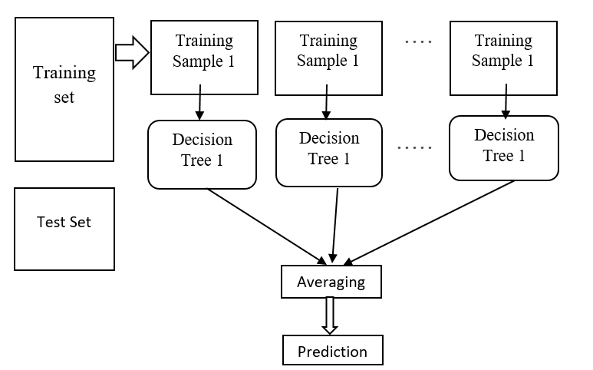

Figure2: Working of Random Forest Algorithm

Key Formulas:
Gini Impurity: Evaluates the frequency at which a randomly chosen element from a group would be incorrectly classified when labeled randomly according to the distribution of labels in that group.
$$Gini :G=1- \sum_{i-1}^{n}{P_{i}^{2}}$$
Measures the impurity of a node, where P_{i} represents the likelihood of a data point being part of class i.
Averaging: Predicts the final value as the average of all tree predictions.
$$Averaging:\hat{y}=1/m \sum_{j=1}^{m}{h_{j} (x)}$$
Where m is the total number of decision tree, x is the input.
- Deep Neural Network: A deep neural network (DNN) is a type of machine learning model that mimics how the human brain processes information. Unlike traditional algorithms that follow predefined rules, DNNs can learn patterns from data and make predictions based on previous experiences.

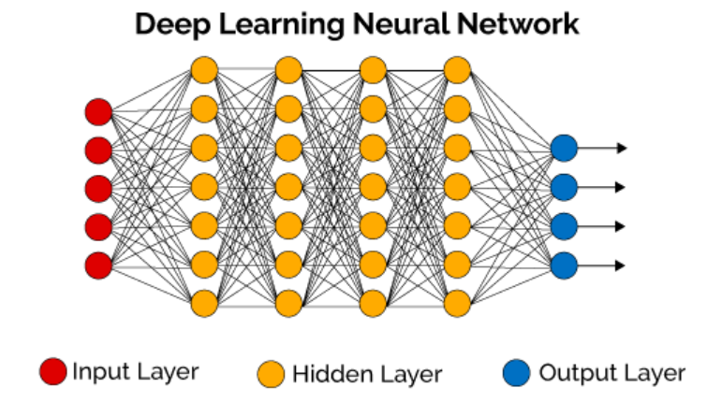

Figure3: Working of Deep Neural Network
Key Formulas:
Linear Transformation: Computes the initial input transformation using weights and biases.
$Linear Transformation :Z=WX+b$
Where X is the linear combination of inputs, W is the weights, b is the bias.
Activation Function: Introduces non-linearity to the model by transforming the linear output.
$$Activation Function:A=σ(Z)$$
Where Z is the linear output.
Weight Update (Gradient Descent): Adjusts the weight based on the computed gradients to minimize the loss.
$$Weight Update:W=W-η\frac{∂L}{∂W}$$

Where W is the weight, η is the Learning rate.
Model Evaluation: The collection is balanced through web scraping or APIs containing genuine and fraudulent job listings. Preprocessing and feature extraction, both at the textual and metadata levels and also including sentiment analysis, are then applied to the data for training Random Forest and Deep Neural Network models. Both models are then examined for efficiency in detecting fraudulent job listings.
CONCLUSION:
Since fraudulent job postings have been on the increase, job seekers are at serious risk. Thus, machine learning and natural language processing-based automated detection systems are a must. This paper reveals how well classifiers like Random Forest and Deep Neural Networks can identify phony job postings. Deep learning and ensemble approaches are gaining popularity as means for enhancing the capabilities of detection further, according to the research. With continually changing scam tactics, the model needs to shift constantly. In conclusion, it is possible to enhance the integrity of online job markets by making available robust systems for detection in place that could give job seekers credible resources toward preventing scammers.
References:
- Baker, J., Smith, R., & Johnson, L. (2020). The Impact of Online Job Scams on Job Seekers. Journal of Cybersecurity, 15(3), 45-60.
- Better Business Bureau (BBB). (2022). Job Scams: A Growing Concern. Retrieved from BBB website.
- Bishop, C. M., & Nasrabadi, N. M. (2006). Pattern recognition and machine learning (Vol. 4, No. 4, p. 738). New York: springer.
- Gonzalez, M., Patel, A., & Lee, K. (2022). Enhancing Job Market Integrity: Machine Learning Approaches to Detect Fake Job Postings. International Journal of Information Systems, 18(2), 112-130.
- Huang, Y., & Chen, X. (2021). Understanding the Dynamics of Job Scams: A Data-Driven Approach. Computers in Human Behavior, 115, 106600.
- Kumar, A., & Singh, R. (2021). Feature Selection Techniques for Fraud Detection in Job Postings. Journal of Data Science and Analytics.
- Alghamdi, B., & Alharby, F. (2019). An intelligent model for online recruitment fraud detection. Journal of Information Security, 10(3), 155-176.
- Amaar, A., Aljedaani, W., Rustam, F., Ullah, S., Rupapara, V., & Ludi, S. (2022). Detection of fake job postings by utilizing machine learning and natural language processing approaches. Neural Processing Letters, 1-29.
- Habiba, S. U., Islam, M. K., & Tasnim, F. (2021, January). A comparative study on fake job post prediction using different data mining techniques. In 2021 2nd international conference on robotics, electrical and signal processing techniques (ICREST) (pp. 543-546). IEEE.
- Huynh, Tin & Nguyen, Kiet & Luu, Ngan & Nguyen, Thuy & Nguyen, Gia-Tuan. (2020). Job Prediction: From Deep Neural Network Models to Applications. 10.1109/RIVF48685.2020.9140760..
- Kumar, A., & Singh, R. (2021). Feature Selection Techniques for Fraud Detection in Job Postings. Journal of Data Science and Analytics, 9(2), 123-135.
- Nasser, I. M., Alzaanin, A. H., & Maghari, A. Y. (2021, September). Online recruitment fraud detection using ann. In 2021 palestinian international conference on information and communication technology (PICICT) (pp. 13-17). IEEE.
- Ratnam, C. V., Kranthi Sri, B., Dhanwanth Sai, D., & Preetham Paul, A. (2022). Predicting Fake Jobs with a Voting Classifier of Multiple Classification Models. International Journal of Food and Nutritional Sciences, 11(12), 1911-1918.
- Sridevi, K. & Likitha, G. & Chandana, P. & Shamarthi, Shrutika. (2024). Real or Fake Job Posting Detection. International Research Journal on Advanced Engineering and Management (IRJAEM). 2. 2499-2504. 10.47392/IRJAEM.2024.0361
- Vidros, S., Kolias, C., Kambourakis, G., & Akoglu, L. (2017). Automatic detection of online recruitment frauds: Characteristics, methods, and a public dataset. Future Internet, 9(1), 6.
- Alghamdi, B., & Alharby, F. (2019). An intelligent model for online recruitment fraud detection. Journal of Information Security, 10(3), 155-176.
- Joyce, S. "major types of scam jobs and job scams online—Job-Hunt. org. Job Hunt." 5,
- Naudé, M., Adebayo, K. J., & Nanda, R. (2023). A machine learning approach to detecting fraudulent job types. Ai & Society, 38(2), 1013-1024.
- Boka, M. (2024). Predicting Fake Job Posts Using Machine Learning Models. Available at SSRN 4807145.
- Anita, C. S., Nagarajan, P., Sairam, G. A., Ganesh, P., & Deepakkumar, G. (2021). Fake job detection and analysis using machine learning and deep learning algorithms. Revista Geintec-Gestao Inovacao e Tecnologias, 11(2), 642-650.

